**PIZZA SALES SQL QUERIES**

1. KPIS
2. Total Revenue

select sum(total_price) as 'Total_Revenue' from pizza_sales;

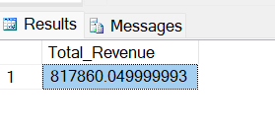

1. Average Order Value

select sum(total_price) / count(distinct order_id) as 'Avg_order_value' from pizza_sales;

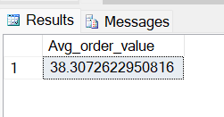

1. Total pizzas sold

Select SUM(quantity) as 'Total_pizzas_sold' from pizza_sales;

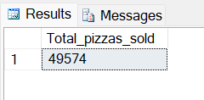

1. Total Orders

select COUNT(distinct order_id) as Total_orders from pizza_sales;

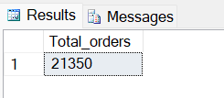

1. Average pizzas per order

select cast(cast(SUM(quantity) as decimal (10,2)) /

cast(COUNT(distinct order_id) as decimal (10,2)) as decimal (10,2)) as 'Avg_pizzas_per_order' from pizza_sales;

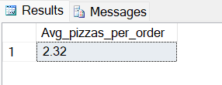

1. Daily trend for total orders

select DATENAME(DW, ORDER_DATE) AS 'Order_day', COUNT(distinct order_id) AS 'Total_orders'

from pizza_sales

group by DATENAME(DW, ORDER_DATE);

Output:

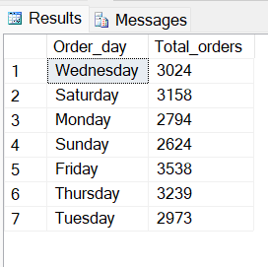

1. Monthly trend for orders

select DATENAME(MONTH, ORDER_DATE) AS 'Month_name', COUNT(distinct order_id) AS 'Total_orders'

from pizza_sales

group by DATENAME(MONTH, ORDER_DATE)

Order by COUNT(distinct order_id) desc;

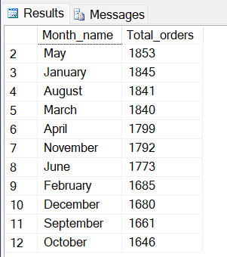

1. Percentage of sales by Pizza category

select pizza_category, sum(total_price) as 'Total_sales', sum(total_price)*100 / (select SUM(total_price) from pizza_sales) as PCT

from pizza_sales

group by pizza_category;

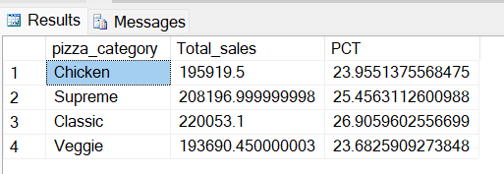

1. Percentage of sales by pizza size

select pizza_size, cast(sum(total_price) as decimal (10,2)) as 'Total_sales', cast(sum(total_price)*100 / (select SUM(total_price) from pizza_sales) as decimal(10,2)) as PCT

from pizza_sales

group by pizza_size

order by PCT DESC;

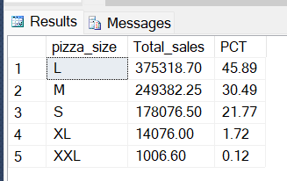

1. Top 5 pizzas by revenue

select top 5 pizza_name, SUM(total_price) as Total_revenue from pizza_sales

group by pizza_name

order by Total_revenue desc;

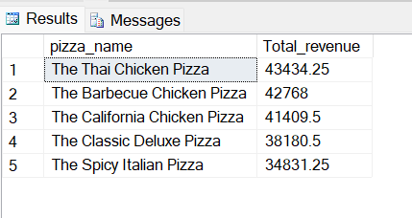

1. Bottom 5 pizzas by revenue

select top 5 pizza_name, SUM(total_price) as Total_revenue from pizza_sales

group by pizza_name

order by Total_revenue;

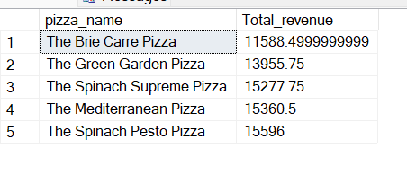

1. Top 5 pizzas by quantity sold

select top 5 pizza_name, SUM(quantity) as Total_quantity from pizza_sales

group by pizza_name

order by Total_quantity desc;

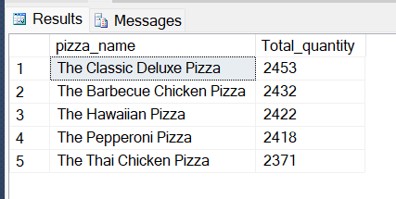

1. Bottom 5 pizzas by quantity sold

select top 5 pizza_name, SUM(quantity) as Total_quantity from pizza_sales

group by pizza_name

order by Total_quantity;

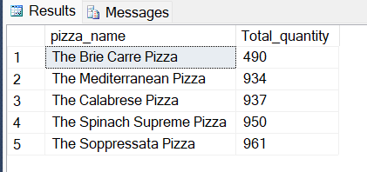

1. Top 5 pizzas by total orders

select top 5 pizza_name, COUNT(distinct order_id) as Total_orders from pizza_sales

group by pizza_name

order by Total_orders Desc;

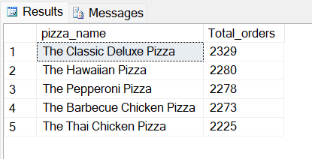

1. Bottom 5 pizzas by total orders

select top 5 pizza_name, COUNT(distinct order_id) as Total_orders from pizza_sales

group by pizza_name

order by Total_orders;

